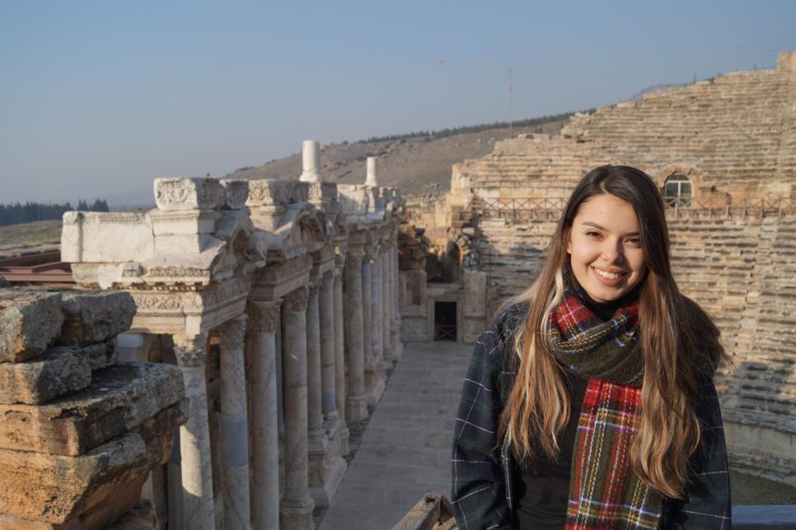

EMİNE BÜŞRA MÜLAYİM

Personal Information

**Phone:**

+90 554 270 11 60

**Email:**

busramulayim1792@gmail.com

**Date of birth:**

12.03.1997

Education:

* Middle East Technical University (METU)- M.S Biology (2022-2024)
* Middle East Technical University (METU) – B.S Biology (2016-2022)
* Hüseyin Avni Sözen Anatolian High School (2011-2016)

Laboratory and Computational Skills

-Microscope, Biologically Important Molecules’ Analysis, Electrophoresis (Agarose and Polyacrylamide gel), DNA Extraction and Cell Fractionation, Respiration (Aerobic and Anaerobic oxidation of organic molecules), Cell Culture and Human Cytogenetics (Differential staining…), Determination of Base Composition of DNA, Inheritance (Mendelian inheritance), Mutation, mode of Action and Resistance Mechanism to Antibiotics, Blood and Blood Cells (Determination of bicarbonate, counting…), Preparation of Buffers, Spectrophotometry, Determination of Purity of Organic Compounds with TLC, Familiarity with PCR and QPCR, Plasmid isolation, agarose gel electrophoresis, Handling Drosophila melanogaster cultures, Introduction to organic chemistry techniques.

-TP, SRP analysis, Chl-a analysis, PVI calculation.

-Office programs, R programming.

Languages

English (Academic Level)

German (A1.2)

Experiences:

Prof. Meryem Beklioğlu’s Limnology Lab 2020 Spring semester-2022 summer as a volunteer and Master Student 2022 summer-present.

Doğa Koruma Merkezi (The Nature Conservation Centre) 2019 Summer Volunteer Internship

Labraunda Excavation 2019 summer volunteer student

Prof. Meryem Beklioğlu’s Limnology Lab 2021 Summer Internship in Ponderful project.