Curriculum Vitae

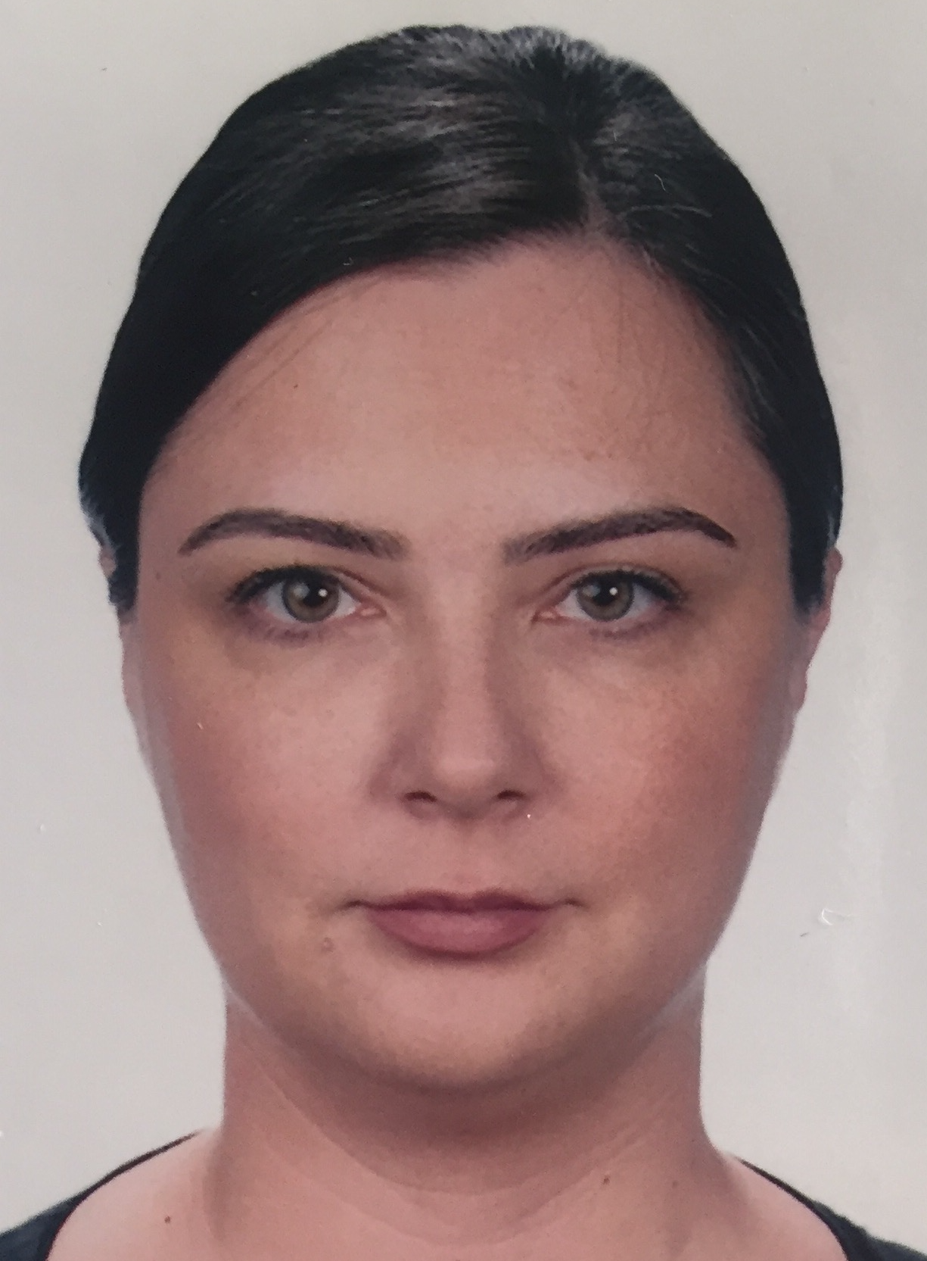
Name & Surname: Dilvin YILDIZ
Nationality: Turkish
Date of birth: Oct.24.1980
Address: Park Oran Sitesi D1/B blok
Daire 11 Oran ÇANKAYA, ANKARA, TURKEY
Mobile no: +90 546 655 2889
E- mail: dilvinim@gmail.com
EDUCATION
- Doctor of Philosophy, Earth System Science, GPA = 3.83, 2018-
Middle East Technical University
Minor: Limnology, Zooplankton
Thesis Title: Effects of Anthropogenic Global Change on Freshwater Lake Zooplankton Community Structure and Diversity: a Mesocosm Approach
Courses: Eutrophication & Restoration of Lake Ecosystem, Community Ecology, Global Biogeochemistry, Climate Change and Modelling, Environment Society and Technology, World Energy Sources, Economics of Energy Sources
- Master of Science, Environmental Enginering, GPA = 3.69, 2009-2012
Istanbul Technical University
Minor: Environmental Biotechnology
Thesis Title: Model based evaluation of biogas production potential of full scale wastewater treatment plants which is operated under low SRT
Courses: Population Dynamics and Modeling of Biological Systems, Aerobic and Anaerobic Treatment Technologies, Nutrient Removal, Morphological, Physiological and Phylogenetic Characterization of Microbial Communities in Environmental Systems, Biological Treatment Technologies for Industrial Wastewaters
- Bachelor of Science, Geology Engineering, GPA = 2.4, 2000-2004
Istanbul Technical University
Thesis Title: Determination of Petrographic Structure of Basalts in Thrace Basin
PROJECTS
- Project : TUBITAK / Resistance, Resilience and Recovery of Lake Microbial and Plankton Community to Climate-Induced High Loads of Terrestrial Dissolved Organic Carbon (tDOC) : Mesocosm Study (Acronym: R3-DOC) , Project lead by Meryem Beklioğlu, 2020-
Position : Researcher
- Project : EU H2020-INFRAIA: AQUACOSM (Project No 731065) - Network of Leading European AQUAtic MesoCOSM Facilities Connecting Mountains to Oceans from the Arctic to the Mediterranean, 2018-
Position : Researcher
1st year experiment : Microplastics – Evaluate negative effects of microplastics in shallow freshwater lakes. Project lead: Meryem Beklioglu. Dates; 01 June-30 Sept 2018
2nd year experiment : Systems responses to recurrent pulses of dissolved organic carbon (DOC). Project lead: Meryem Beklioğlu, Gülce Saydam and Dilvin Yıldız. Dates; 01 May-31 July 2019.
3rd year experiment: Determining the effects of high DOC and warming on the microbial and planktonic food web structure and efficiency. Project lead: Meryem Beklioğlu, Gülce Yalçın and Dilvin Yıldız.
Responsibilities: Research and organization of the mesocosm experiments. Organization of the designed mesocosm experiments for each year such as: decision/purchasing/maintenance of experimental materials, organization and scheduling field trips, instalment/ preparation and maintenance of mesocosm platform and tanks, following of permissions/official correspondence; also, organization of samplings, analyses and data processing, statistical analyses etc.
PROFESSIONAL EXPERIENCE
- Company : NARTUS ENERGY AND CONSULTANCY CO. (4 months)
Position : Project Consultant
Sector : Environmental and Energy Consulting
Job Description : Responsible for all period of Environmental reports such as; Environmental and Social Impact Assessment (ESIA), Environmental Management Plan (EMP), Due Diligence Report, Accommodation Plan, - for both Turkish Government, and financial corporations like IFC. In detail, the period includes; Preparation of the report.
- Company : ENCEV ENERGY AND CONSULTANCY CO. (2 years)
Position : Project Consultant
Sector : Environmental and Energy Consulting
Job Description : Responsible for all period of Environmental reports such as; Environmental and Social Impact Assessment (ESIA), Environmental Management Plan (EMP), Due Diligence Report, Accommodation Plan, - for both Turkish Government, and financial corporations like IFC. In detail, the period includes; Preparation of the report, - Establish and maintain environmental stakeholder relationship, Carry on ongoing negotiations with clients, contractors, other consultants providing project management expertise and authorized people working for institutions. To receive a price quote from other consultant companies on demanded subjects, review and evaluate them during preparation of the report.
PUBLICATIONS
- Jelena Stanković, Djuradj Milošević, Dimitrija Savić-Zdraković, Gülce Yalçın, Dilvin Yildiz, Meryem Beklioğlu, Boris Jovanović, Exposure to a microplastic mixture is altering the life traits and is causing deformities in the non-biting midge Chironomus riparius Meigen (1804), Environmental Pollution, Volume 262, 2020, 114248, ISSN 0269-7491, https://doi.org/10.1016/j.envpol.2020.114248.
CONFERENCES
- Dilvin Yıldız, Gülce Yalçın, Meryem Beklioğlu. Mesocosm experiment on effects of microplastic on freshwater zooplankton community. Ecology and Evolutionary Biology Symposium 2019. 10.07.2019, Ankara, Türkiye.
- Dilvin Yıldız, Gülce Yalçın, Boris Jovanovıc, Derya Öztürk, Lucie Vebrova, David Boukal, Djuradj Mılosevıc, Dimitrija Savıc, Jelena Stankovıc, Jessica Rıchardson, Heidrun Feuchtmayr, Meryem BEKLIOĞLU. First in-situ mesocosms experiment for investigating impacts of microplastics on littoral food web. 11th Symposium for European Freshwater Sciences (SEFS), 05.07.2019, Zagreb Hırvatistan.
- Gülce Yalçın, Dilvin Yıldız, Boris Jovanovic, Derya Öztürk, Lucie Vebrová, David Boukal, Djuradj Milošević, Dimitrija Savić, Jelena Stanković, Jessica Richardson, Heidrun Feuchtmayr, Melisa Metin, Deniz Balkan, Yasmin Akyürek & Meryem Beklioğlu. In-situ Mesocosms Experiment for Investigating Impacts of Microplastics on Food Web of Shallow Lakes. ASLO 2019 Planet Water – Challenges and Successes, 02.03.2019, San Juan, Puerto Rico.
- B.Jovanovich, J.Stankovic, D.Milosevic, D.Savic, A.Savic, G.Yalcin, D.Yildiz, D.Öztürk, L.Vebrova, D.Boukal, M.Beklioglu. “Comperative Indoor Outdoor Study Microplastic Effects on Non-Biting Midges (Diptera: Chironomidae) (Poster Presentated at ASLO meeting, 2018, Puerto Rico)

CERTIFICATES and TRAINING
- R workshop , 2018, R- beginner training
- ISO 14001 Environmental Management Systems Certificate
- Environmental Specialist Certificate (Ministry of Environment and Urbanization)
- Work Health and Safety Specialist Certificate (Ministry of Labour and Social Security)
- Project Cycling Management (PCM) Certificate (AB-ilan)
LANGUAGE SKILLS
- Turkish (mother tongue)
- English
- Russian (as beginner)
COMPUTER SKILLS
- R-project for statistical computing
- Aquasim for Environmental Engineers
- Biowin wastewater treatment systems design program
- Microsoft Office, including Word, Excel, Power Point and Access
OTHER INTERESTS • Shamanizm, Yoga, European Paint Art, Psychology
ACADEMIC REFERENCES
- Prof.Dr. Meryem BEKLİOĞLU (METU, Biological Sciences, Ankara), e-mail: meryem@metu.edu.tr

- Prof.Dr. Aysen YILMAZ (METU, Earth System Science Department, ODTU Yerleskesi, Ankara), e-mail: ayilmaz@metu.edu.tr

- Prof. Dr. H.Guclu INSEL (ITU Environmental Engineering Department, Maslak,Istanbul,Turkey), e-mail: inselhay@itu.edu.tr

