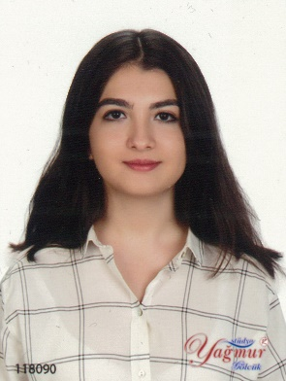
FERİDE AVCI
E-mail: ferideavci18@gmail.com
Mobile phone: +905302024650

Date of Birth: 18.10.1998
Education
- 2016-2020: BSs in Molecular Biology and Genetics Middle East Technical University (METU), Ankara, Turkey. CGPA:3.02/4.00
- 2012-2016: Kocaeli Bahçeşehir High School (Highest Ranked Student). CGPA:96.78/100
- 2015: IELTS (Score: 7.5/9.0)
Languages
Turkish (Native)
English (Advanced)
German (Beginner)
Computer Skills
RStudio (Beginner)
MS Office (Advanced)
Laboratory Experience
Related wet-lab experience
- Molecular genetics
- Isolation of plasmids, DNA and total RNA, bacterial transformation, restriction enzyme digestion, spectrophotometry, cDNA synthesis, primer design, PCR
- Microbiology
- Preparation of selective and differential media, inoculation by pour, spread & streak plate techniques, staining procedures
- Bioanalytical Chemistry
- Titration methods employing EDTA, Kjeldahl method, thin layer chromatography, gel permeation chromatography, SDS-PAGE, agarose gel electrophoresis, gravimetric analysis, iodometry
- Insect handling
- Handling Drosophila melanogaster culture
- Gene manipulation
-Working with Saccharomyces cerevisiae
- Experience in field work related to mesocosm studies

Traineeship
Summer 2019: METU Mesocosm System collaboration project with AQUACOSM with interest in systems responses to recurrent pulses of dissolved organic carbon (DOC) under supervision of Prof. Meryem Beklioğlu.
Continuous volunteer in METU Limnology Lab since October 2018.
Extra-curricular Activities
Volunteer at LODOS: A student society which aims to spend time with and befriend children with leukaemia, autism, Down syndrome and cerebral palsy.
Certification and Additional Training

Synthetic Biology Day seminar held on October 7, 2017 by Bilkent-UNAMBG iGEM 2017 Team at UNAM, Bilkent University
Following departmental seminars held on the spring semester of 2018 at METU Department of Molecular Biology and Genetics:
Ancient DNA: a 'Time Capsule' to reveal and reconstruct history of populations by Dr. Füsun Özer and Assoc. Prof. Dr. Mehmet Somel on February 28, 2018
Genetic and chemical biology approaches to modulate specific neuronal pathways crucial for neurodegenerative or neurotoxic conditions by Dr. Erkan Kiriş on March 07, 2018
Learning to sing: how function of the song shapes development by Dr. Çağlar Akçay, Koc University on April 13, 2018

All departmental seminars organized by METU Department of Biological Sciences in 2019 and 2020

METU Presidential Lecture with Prof. Peter Agre on October 14, 2019

